CIS30A Lab 2: String Methods, Controlled Statements, List, Tuple and Dictionary
In this assignment, we will cover concepts related to string methods, controlled statements, list, tuple and dictionary. Refer to Week 2 notes, lecture videos and lab videos for explanation and examples. Complete the following tasks or questions. **Note: This lab should be completed after Python packages have been installed. See Week 1 materials for instructions to install Python packages and writing programs.
All exercises require screen captures of script and output for submission.

String Sequencing and Built-in Methods

- Write a Python script that contains a variable that holds your first name and add statements to fulfill the following tasks:
- Display the first and last letter of your first name using index.
- Display the number of characters in your first name.
- Display the first to third letter of your first name using index.
- Display the second to last letter of your first name using index.
- Display the second to last letter of your first name using len().
Provide screen capture of script and output.
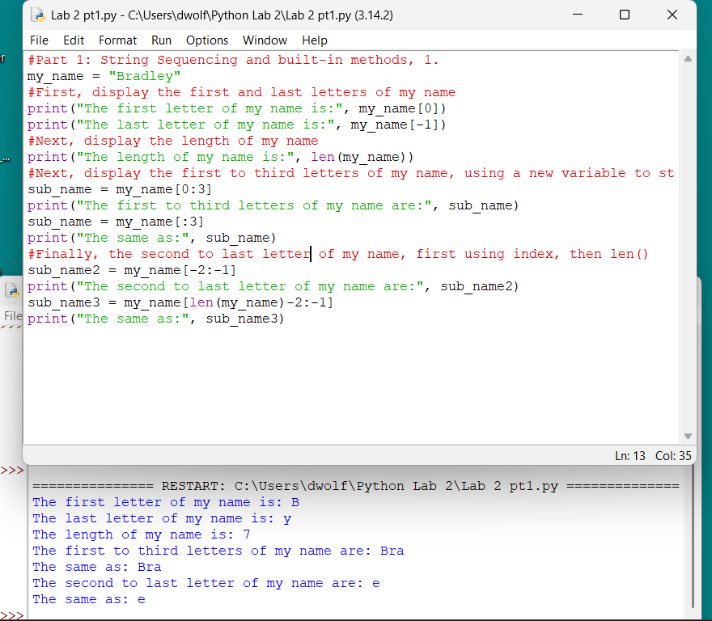
- Write a Python program that contains a variable, state_name = “Indianapolis”, use count() to show the number of ‘i’ in the string. Provide screen capture of script and output.
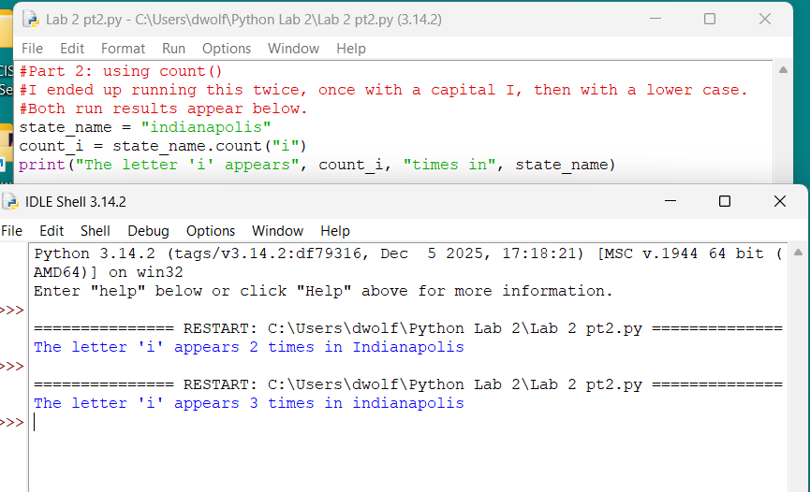

- Write a Python program that contains the string “I am a college student”. Use replace() to substitute “college” with “CIS”. Provide screen capture of script and output.
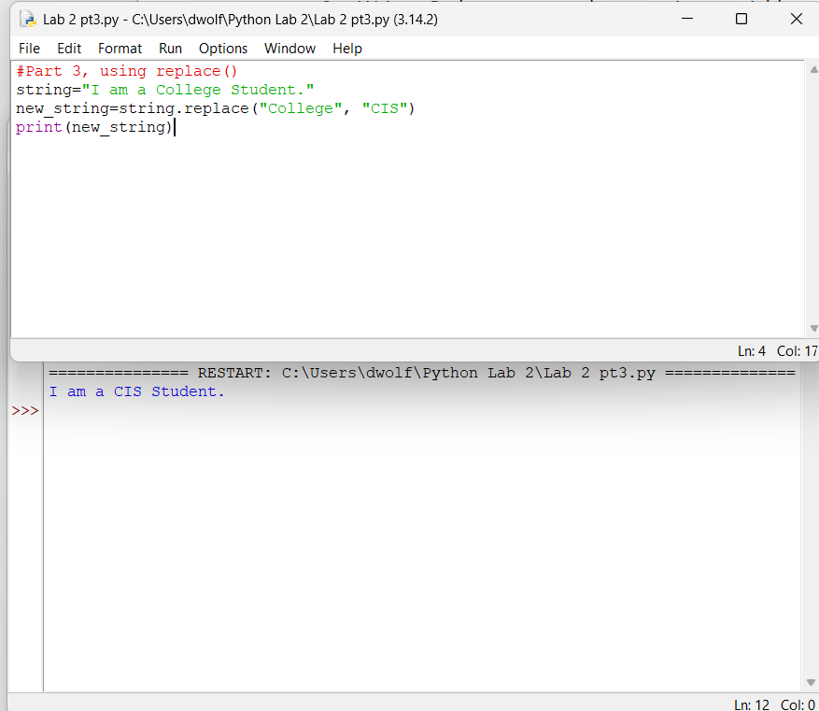

- Write a Python program that uses lower() and upper() to display your full name in lower-case and upper-case letter. Provide screen capture of script and output.
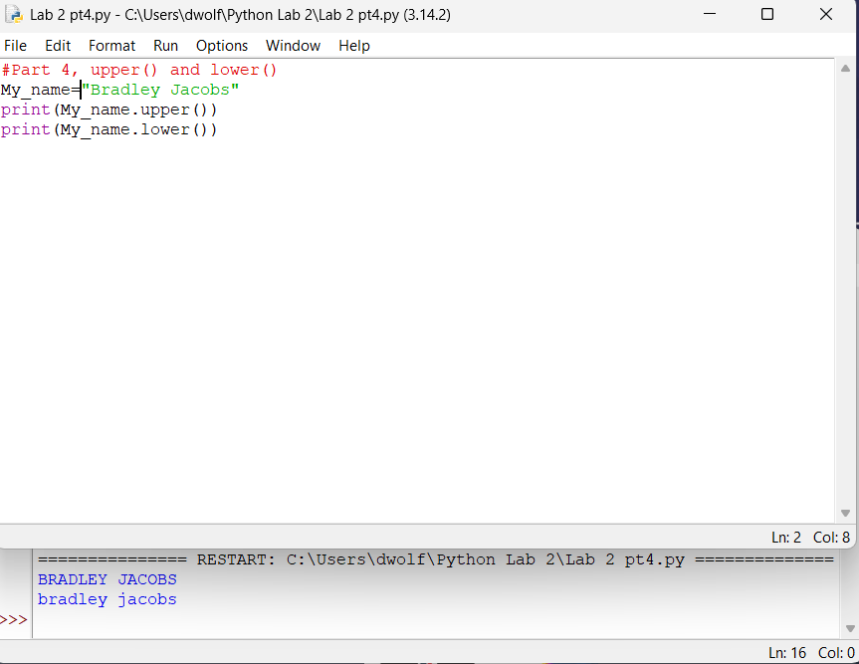
- Write a Python program that uses join() to display a list of your family member names, each name should be separated by “#”. Provide screen capture of script and output.
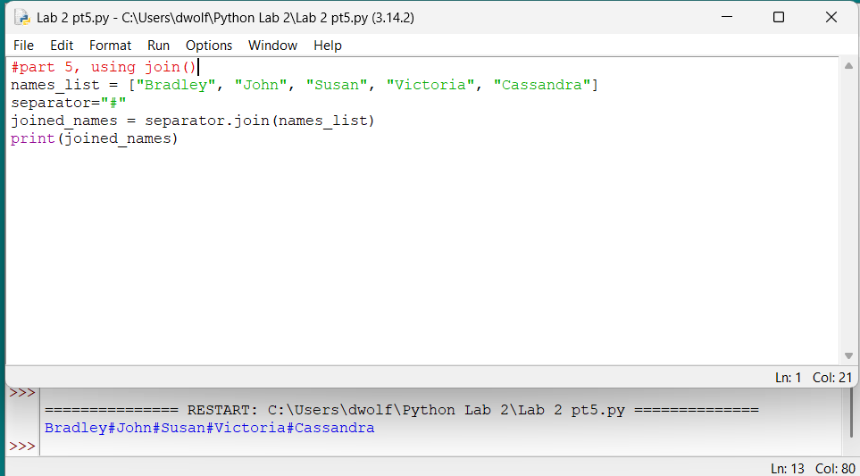

- Write a Python program that uses startswith() to search your full name for your first initial. For example: search for “J” in “John Jones”.
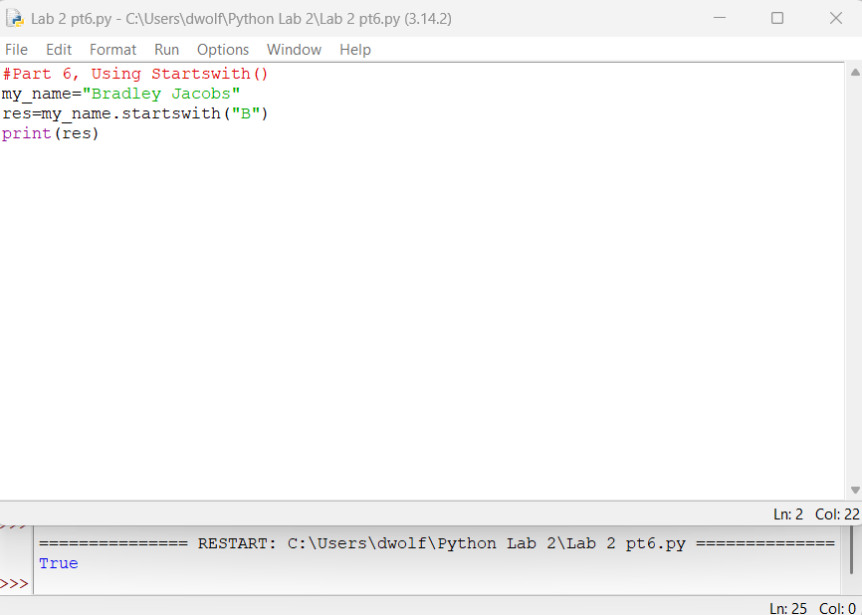

- Write a Python program that contains 3 variables: user_name, user_age, user_address. Assign values to the variables and complete the following tasks:

- Use isalpha() to check if the user_name contains only alphabets.
- Use isdigit() to check if the user_age contains only numbers.
- Use isalnum() to check if the user_address contains alphanumeric values.
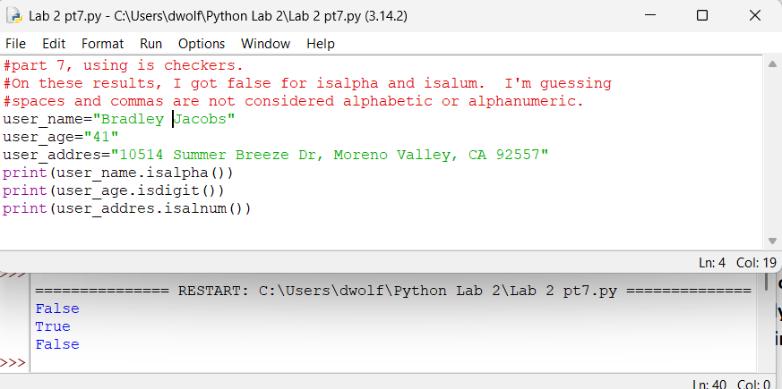

String Slicing
Slicing: obtaining a sub-string from the given string by slicing it respectively from start to end.
- String slicing can be done using slice() constructor or extending Indexing
  - The slice() constructor creates a slice object representing the set of indices specified by range(start, stop, step).
    - Syntax:
      - slice(stop)
      - slice(start, stop, step)
      - start: Starting index where the slicing of object starts.
      - stop: Ending index where the slicing of object stops.
      - step: It is an optional argument that determines the increment between each index for slicing.
      - Example:
str1 = "Python"
fs = slice(4)
ss = slice(1, 3, 5)
ts = slice(-1, -3, -6)
print(str1[fs])
print(str1[ss])
print(str1[ts])
Output:
Pyth
y
n

- Given a string “America, land of the free.”. Write a Python program that uses slice() constructor to do the following:
- Use index sequencing in object to display “America”
- Use reverse index sequencing (negative) in an object to display “free”
- Use index sequencing in an object to display the second, fourth and every other following characters of the string. Hint: use start, stop and step.
Provide screen capture of script and output.
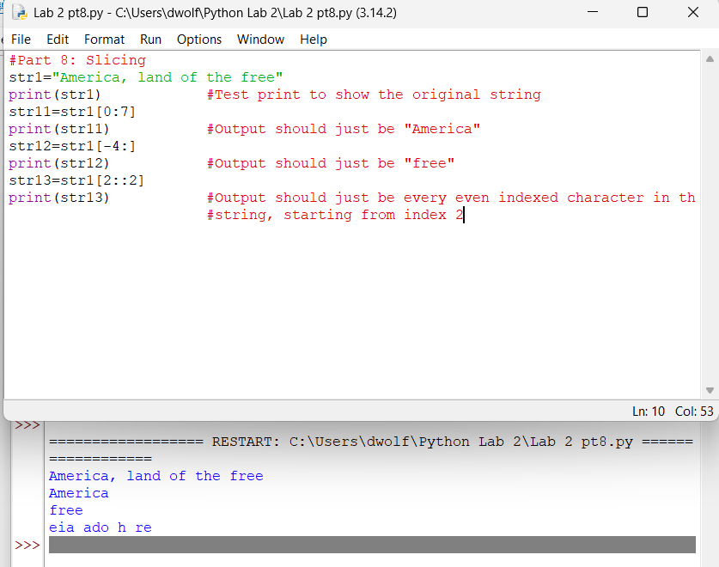

Membership Operator
- Membership operators are used to test if a sequence is presented in an object
  - in: Returns True if a sequence with the specified value is present in the object, x in y
    - Example:
fruits = [“apples”, “oranges”, “banana”]
print(“banana” in fruits)
Output: True
  - not in: Returns True if a sequence with the specified value is not present in the object, x not in y
    - Example:
fruits = [“apples”, “oranges”, “banana”]
print(“grapes” not in fruits)
Output: True
Numbers = [1, 2, 3, 4, 5]
print(100 not in Numbers)

- Given the string: “No pain, no gain!?!”. Write a Python program that uses replace() to remove all the punctuations from the given string. Hint: Use for and if statements.
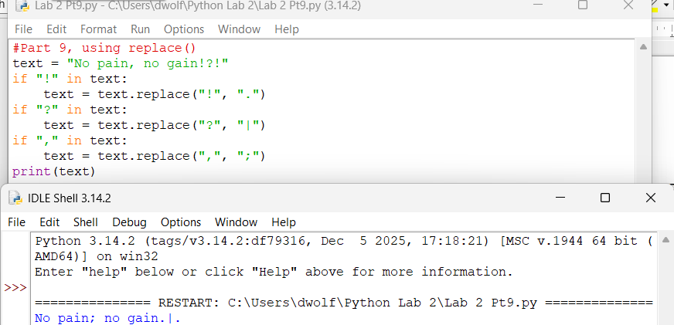
Provide screen capture of script and output.

len()
- Given the string: “PythonPython”. Write a Python program that split the string into 2 equal sub-strings, then display the substrings. Provide screen capture of script and output.
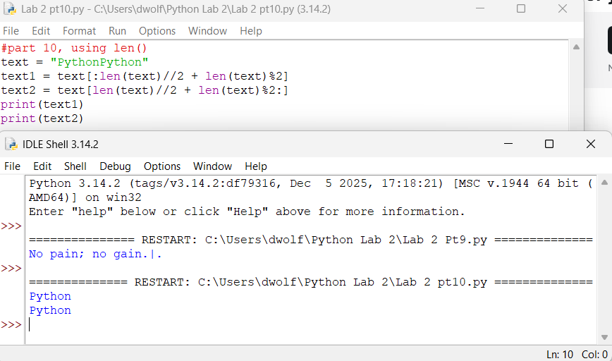

Controlled Statements
- John is 21 years old, write Python program to check if John’s age is older than 18 years of age. Program should contain IF statement. Provide screen capture of script and output.
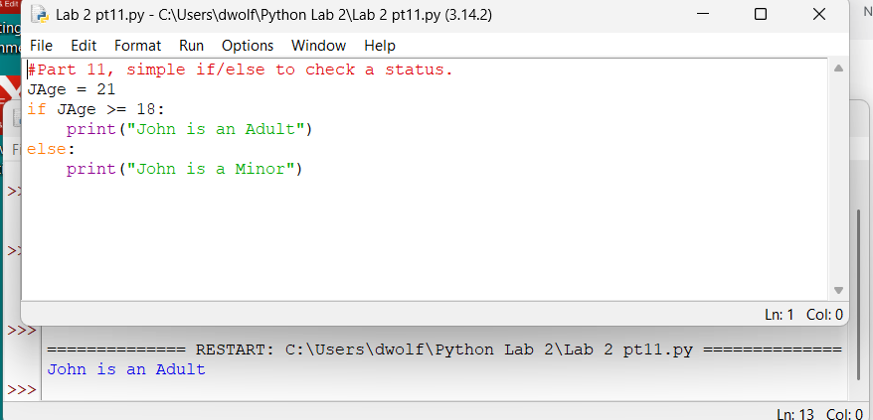

- Store A sells a 50” LCD TV for $400 and charges for shipping. Store B sells the same LCD TV for $530 and provides free shipping. The television weights 65 lbs. and shipping company charges $1.25 per pound to ship the TV. Write a Python program that determines which store charges less for the TV. Program should contain IF-ELSE statement. Provide screen capture of script and output.
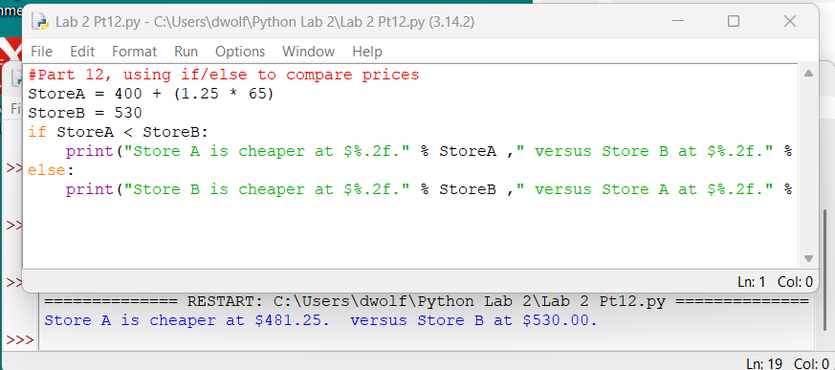
- Marcella receives the following grades on her math assignments: 82, 91, 79, 63, 97. Write a Python program that determines Marcella’s average assignment grade, given the following scale:
- Grade A: 90 to 100
- Grade B: 80 to 89
- Grade C: 70 – 79
- Grade D: 60 – 69
- Grade F: below 60
Program should contain IF-ELIF-ELSE statements. Provide screen capture of script and output.
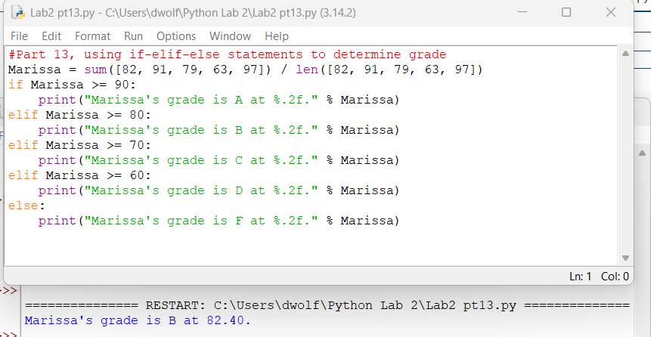
- In a diet plan, a client loses 10 pounds the first month, 12 pounds the second month, 8 pounds the third month and 5 pounds the fourth month. Write a Python program that uses a FOR loop to find the total weight that the client loses over 4 months. Provide screen capture of script and output.
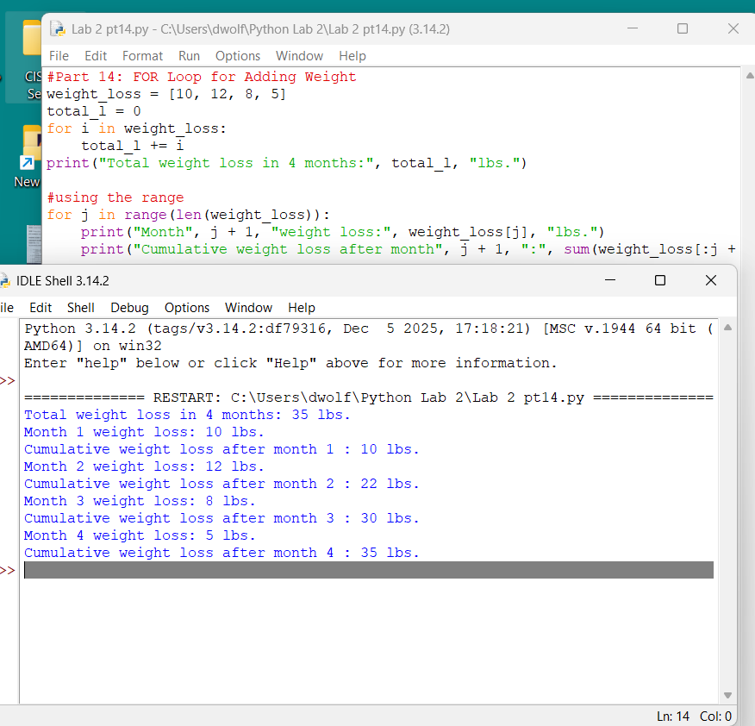
- Given a range of number 0-100, write a Python program using range() to print all even values from 0. Provide screen capture of script and output.
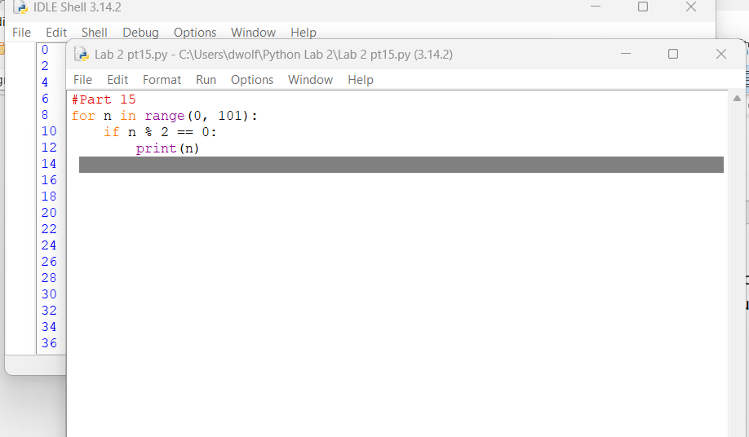
- At a restaurant, Katie orders the following items:

- a burger, $9.99
- milkshake, $5.25
- fries, $2.75
- 2 tacos, $2.99
- nachos, $5.25
- lemonade, $3.75
Write a Python program that determines the subtotal of Katie’s order. Program must use WHILE loop. Provide screen capture of script and output.
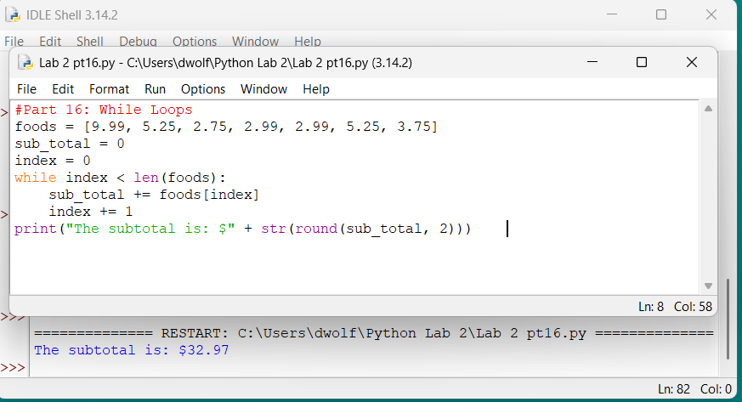
- Write a Python program that does the following
- Generate numbers 0 – 20. Use break statement to stop the loop at the 11th number. Provide screen capture of script and output.
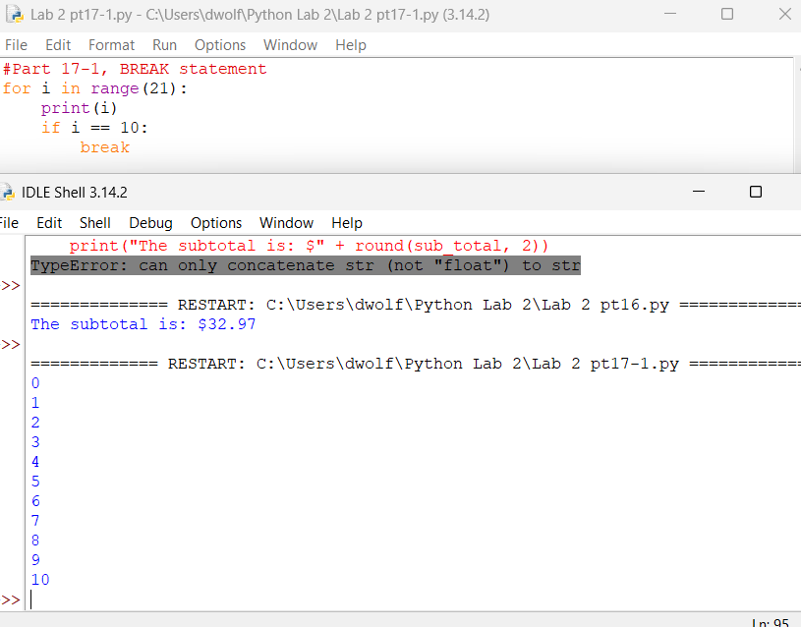
- Generate numbers from 0 – 25. Use continue statement skip number 20 in the iteration. Provide screen capture of script and output.
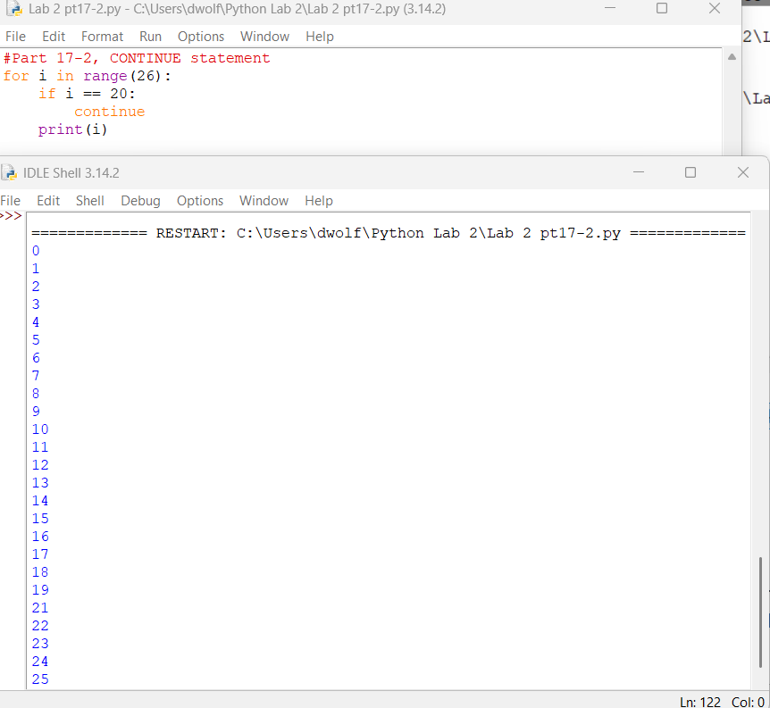

List, Tuple and Dictionary

- Given: nums = [100, 200, 300, 400, 500]. Write a Python program that changes the elements to [100, 300, 500, 700, 900]. Provide screen capture of script and output.
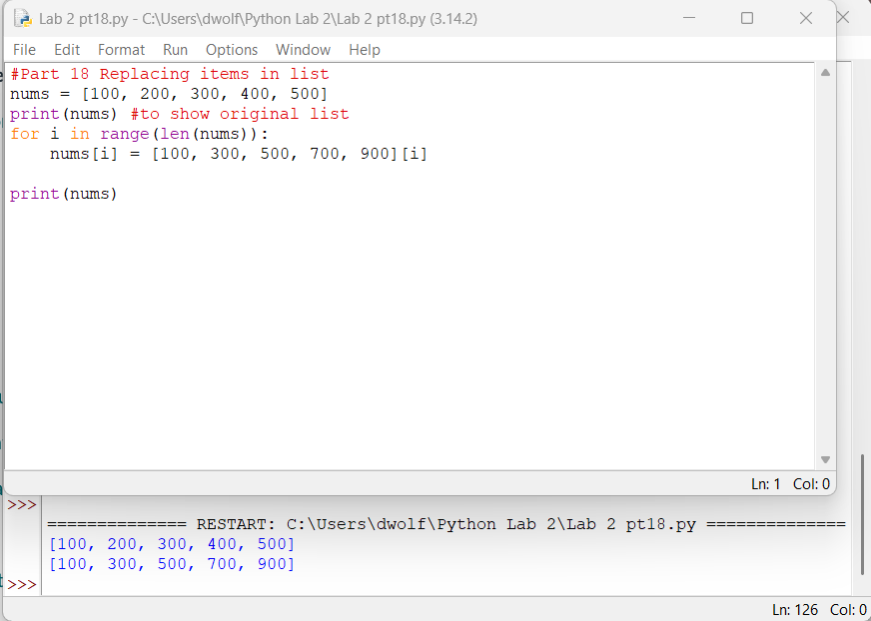

- Given: animals = [‘dogs’, ‘cats’, ‘birds’]. Write a Python program that fulfills the following criteria:

- Add ‘rabbits’ to the list. Display the updated list.
- Add ‘hamster’, ‘turtles’, ‘fishes’ to the list. Display the updated list.
- Use (+) operator to include ‘birds’, ‘snakes’ in output.
- Display the updated list 3 times.
Provide screen capture of script and output.
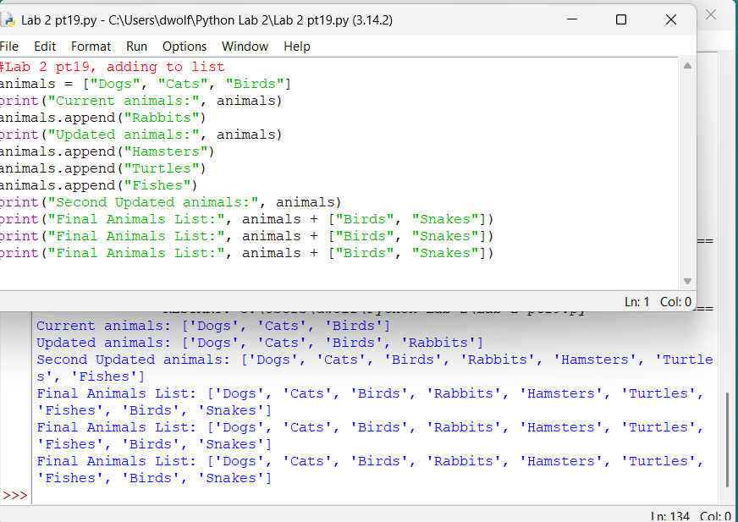
- Given the below list, which contains student names and correlated ages:
- students = [[‘Jack’, ‘Lisa’, ‘Tomas’, ‘Daniel’],[22, 27, 30, 19]]
Write a Python program that fulfills the following criteria:
- access the list using a FOR loop to display the names and age of the students.
- Display second name and age: Lisa, 27.
Provide screen capture of script and output.
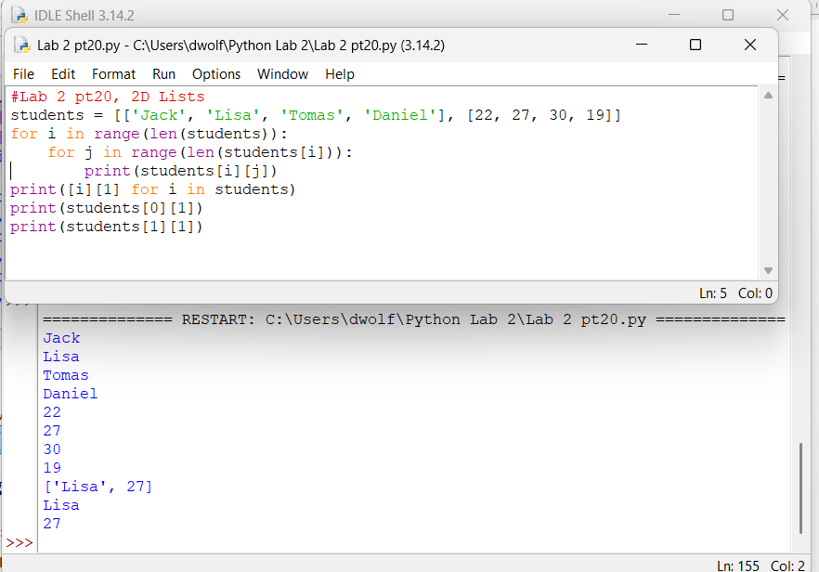
- Declare a tuple and assign 5 values: 8, 11, 26, [32, 46]. Replace [32, 46] with [59, 66], then display the updated tuple. Provide screen capture of script and output.
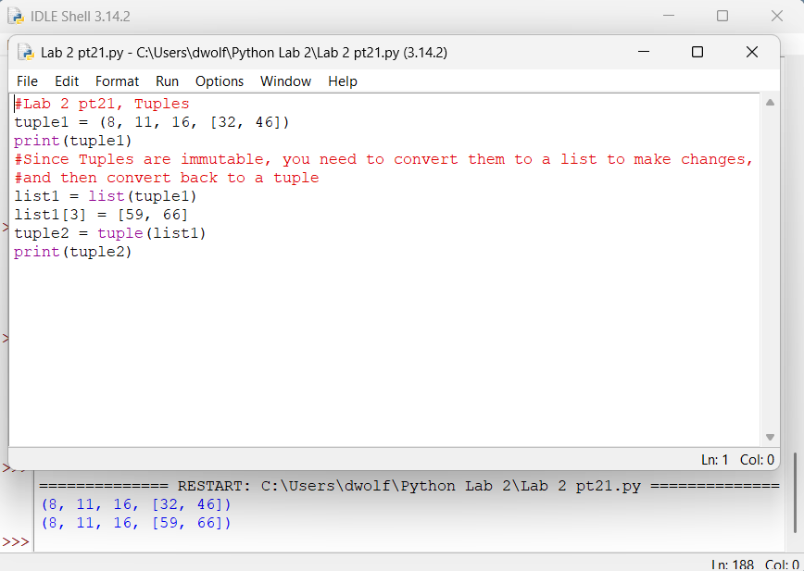
- Write a Python program to fulfill the following criteria:
- Create a dictionary with the below key and values:
- name: John Doe
- ID: 999999
- Course: CIS30A
Print the dictionary
- Add an item: Semester: Fall 2020. Print the updated dictionary.
- Change Course value to ‘Python’. Print the updated dictionary.
- Remove ID from the dictionary. Print the updated dictionary.
- Use popitem() to remove the last item in the dictionary. Print dictionary.
- Clear all items in dictionary. Print dictionary.
Provide screen capture of script and output.
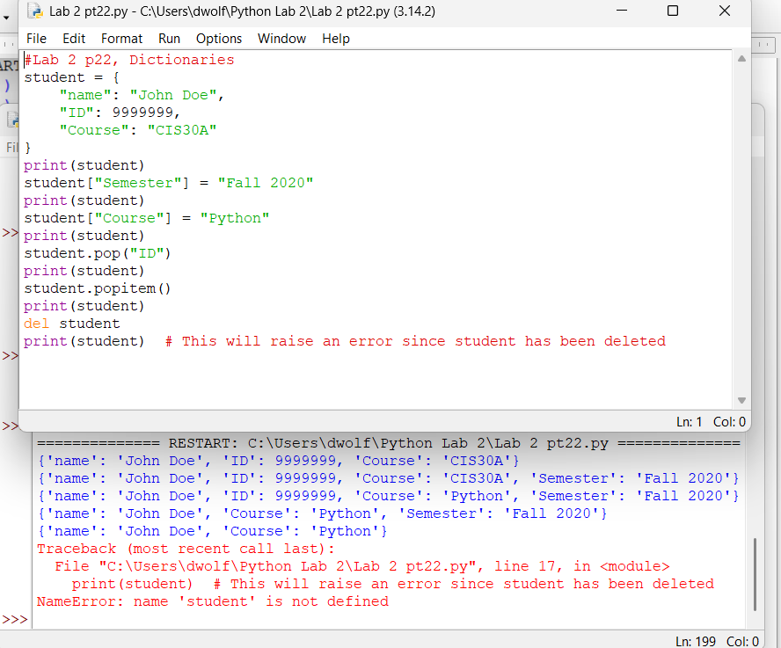

- The Hernandez family has 5 children: Pablo, Leila, Jorge, Karla and Samuel. Use Python list to display each child full name.
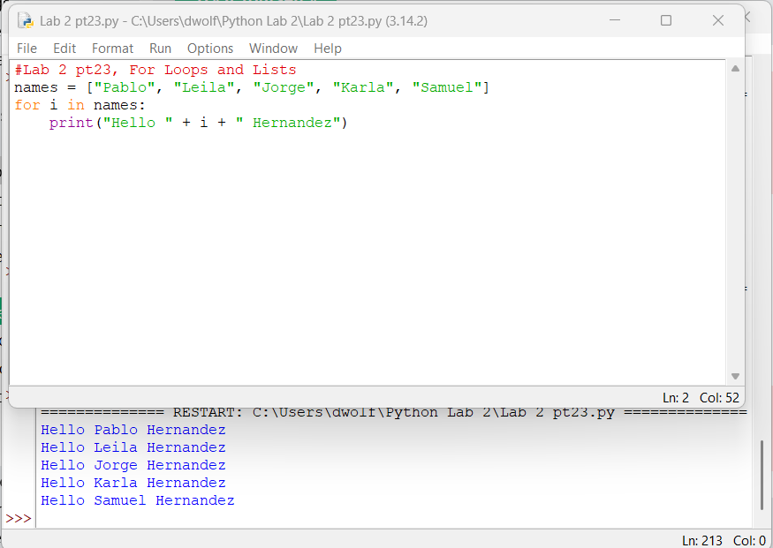
- Given the tuple nums = (10, 20, 30, 40), create a Python list that will have the values of the nums tuple plus 10 to each element and then print the new list with the updated values.
Hint: Your output should look like: [20, 30, 40, 50]
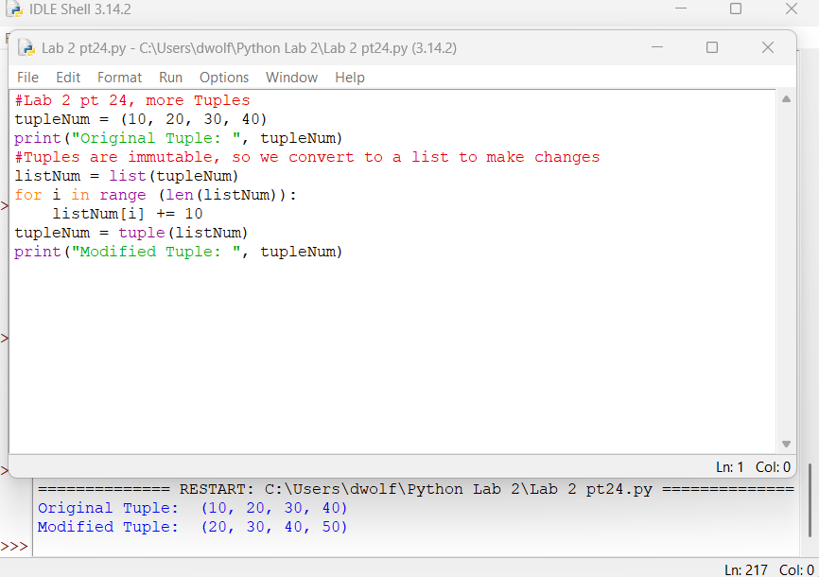

- Maria is saving for her vacation. During the first year, she saves the following: $200, $320, $180, $210, $175, $305. In the second year, Maria is able to save $550, $285, $195, $410. Use Python lists, without using sum(), write a program to determine which year Maria saved the most.
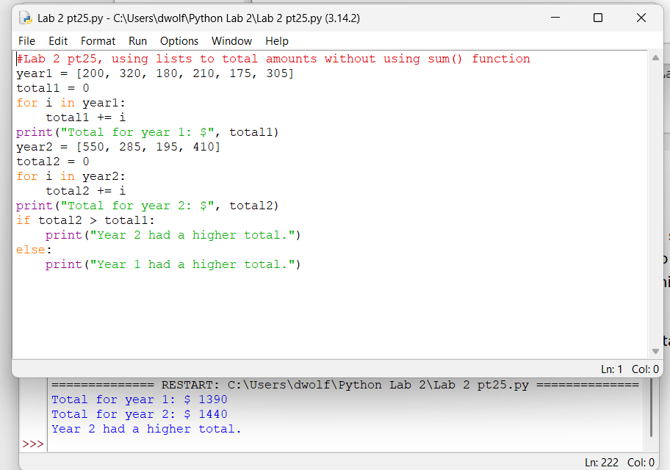

Login Canvas and submit a document (.docx or .pdf) that contains screen captures of SCRIPT and OUTPUT of the above exercises.

